Code Basis RPC 17 Project Documentation
1) There are total 7 tables in which 2 are dimension table and 5 are fact table
2) I Uploaded them in sql one by one and created a data model in sql in city total 4 columns in whch city_id is primary key then ad_category which has ad_category_id is primary key . Applied foreign key constraints of same in fact table using alter and ADD CONSTRAINT COMMANDS. Changing the data types of columns using modify . Also created index of all foreign key for faster retrieval. Facts tables are pilot,sales,ad_revenue,city_readiness. I Solved the business question given by the codebais team there was total 6 question . sql keywords used are CTE,COALESCE , JOINS GROUP BY , TEXT FUNCTIONS , WINDOW FUNCTION FOR RANKING .
Some of the question was -
Business Request – 1: Monthly Circulation Drop Check
Generate a report showing the top 3 months (2019–2024) where any city recorded the sharpest month-over-month decline in net_circulation.
Fields:
- city_name
- month (YYYY-MM)
- net_circulation
Answer
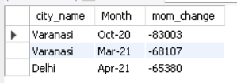
Business Request – 2: Yearly Revenue Concentration by Category
Identify ad categories that contributed > 50% of total yearly ad revenue.
Fields:
- year
- category_name
- category_revenue
- total_revenue_year
- pct_of_year_total
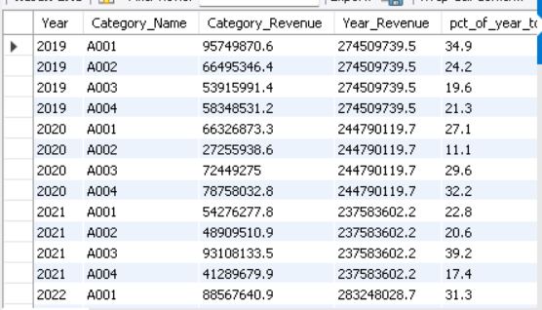
Business Request – 3: 2024 Print Efficiency Leaderboard
For 2024, rank cities by print efficiency = net_circulation / copies_printed. Return top 5.
Fields:
- city_name
- copies_printed_2024
- net_circulation_2024
- efficiency_ratio = net_circulation_2024 / copies_printed_2024
- efficiency_rank_2024
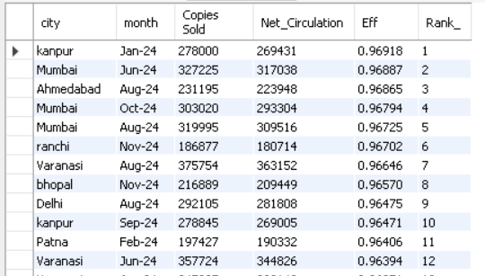
4) Then I Uploaded the data in PBI Using MYSQL Connecter functionality in powerbi
5) Created a Data Model
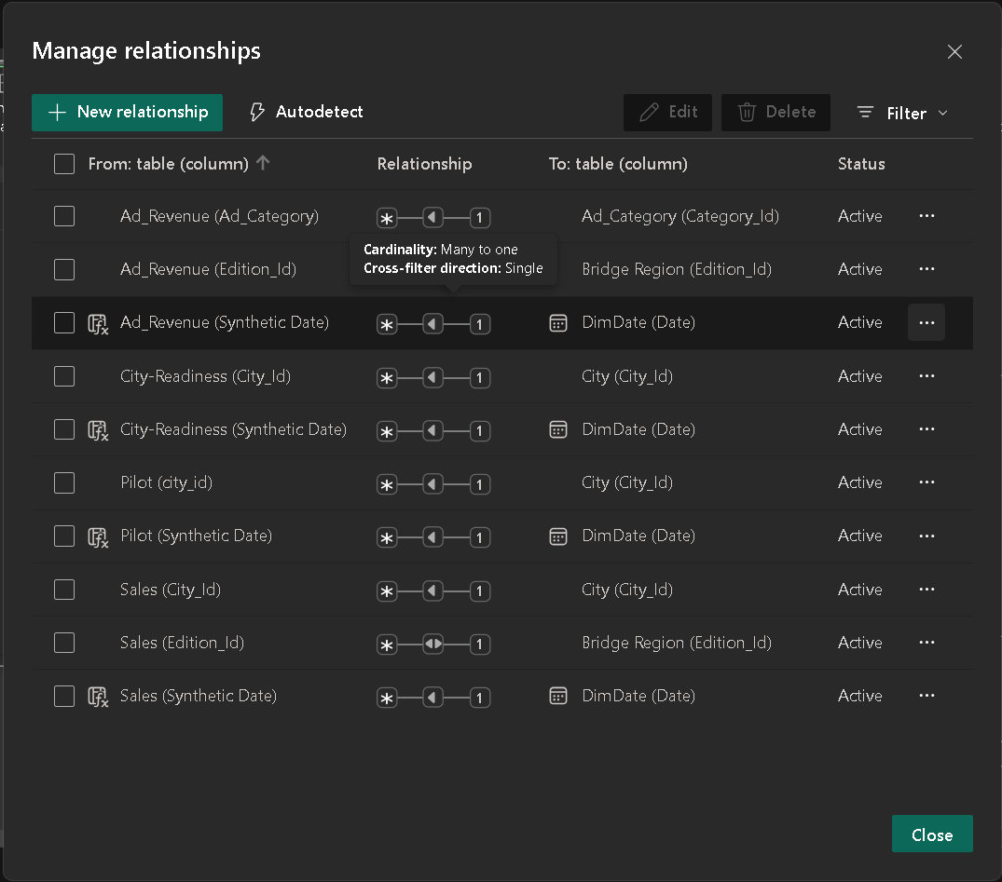
This are the questions for pbi
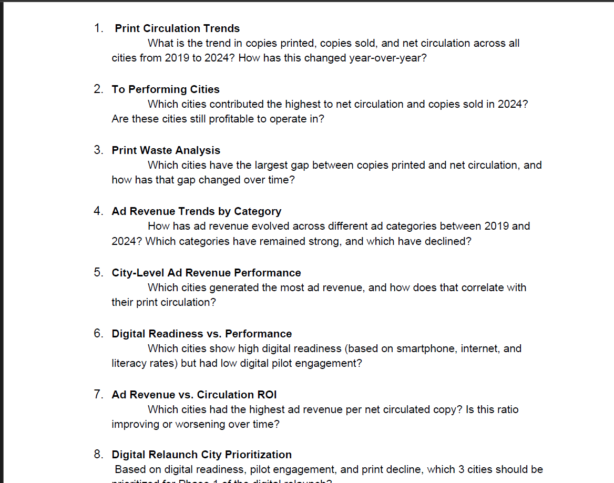
SO ICreated a two Dashboards for this
